Potree Instructions:

Remote in to Web Server, be sure to have you Lidar drive checked on in Local Resources: More

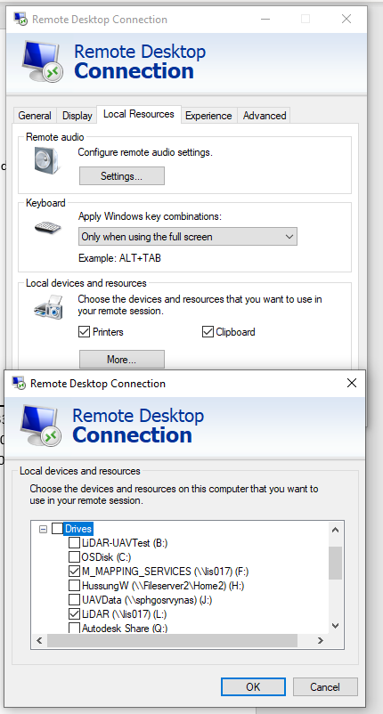

spocarcweb1201

UN: ArcGISAdmin

PW: Esriadmin1!@

Copy LAS file from Lidar drive to the Server’s Data folder located here:

D:\inetpub\wwwroot\Potree\Data

Copy time may pause with around 5 seconds left and appear to hang up, this is “normal”

Bring up Command Prompt:

Change Drive and directories as shown:

d:

cd inetpub\wwwroot\Potree\PotreeConverter_1.6_windows_x64

Replace the las file name and the desired name of the Potree app (will be the name of the converted pointcloud as well as the HTML page) and copy this text:

PotreeConverter.exe D:/inetpub/wwwroot/Potree/Data/**Las_File_Name_No_Spaces**.las -o D:/inetpub/wwwroot/Potree/1.6 --projection "+proj=lcc +lat_1=33.88333333333333 +lat_2=32.78333333333333 +lat_0=32.16666666666666 +lon_0=-116.25 +x_0=2000000.0001016 +y_0=500000.0001016001 +ellps=GRS80 +datum=NAD83 +to_meter=0.3048006096012192 +no_defs " --edl_enabled --generate-page **Potree_File_Name_no_spaces**

In the command prompt, right click in the window and select paste. Control-V will not work.

If you need to replace an existing pointcloud, delete the pointcloud folder you wish to replace from the here: D:\inetpub\wwwroot\Potree\1.6\pointclouds and delete the HTML file that was created here D:\inetpub\wwwroot\Potree\1.6

If this is a new project with a stand alone point cloud these are the edits that need to be made to the HTML file:

Set the Point Budget to 10,000,000

Select the line viewer.toggleSidebar(); and replace with this text:

$( "button:contains('D')" ).hide();

$( "button:contains('T')" ).hide();

$('#navigation > img:nth-child(1)').click();

//viewer.toggleSidebar();

});

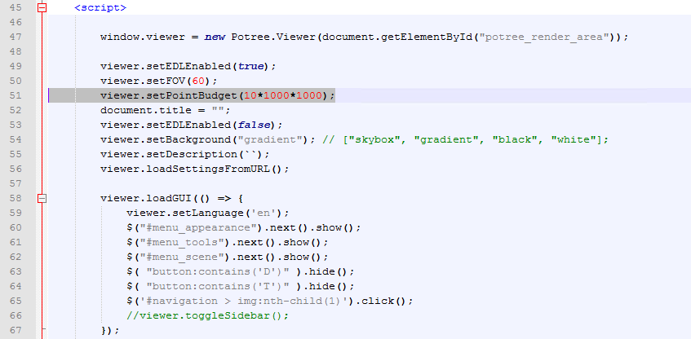

This is what it should look like

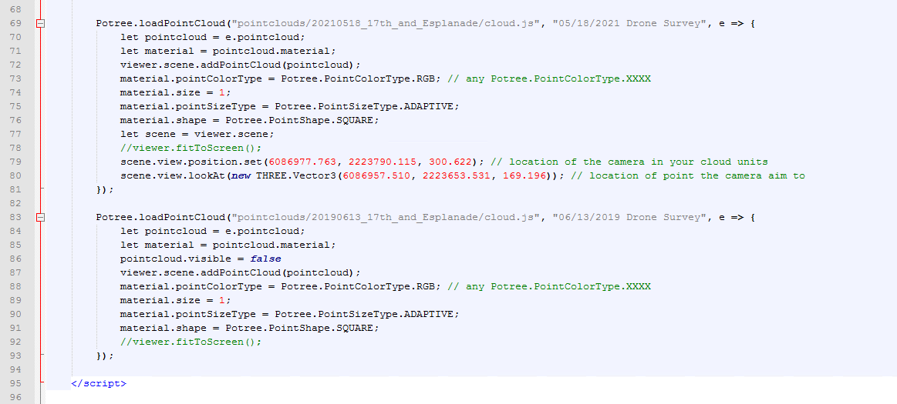

Click the note icon to copy the “position” and “target” coordinates to paste in the position.set and lookAt rows in the HTML file

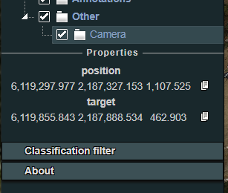

Tags in quotations after the point cloud path will be the label displayed in the application sidebar. By default it will be the pointcloud name.