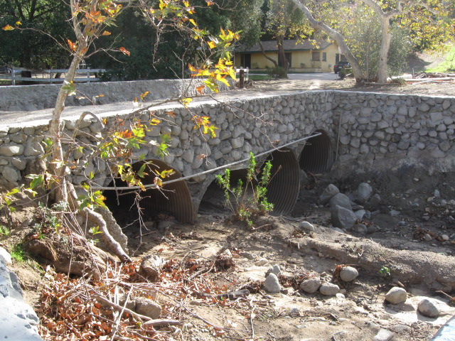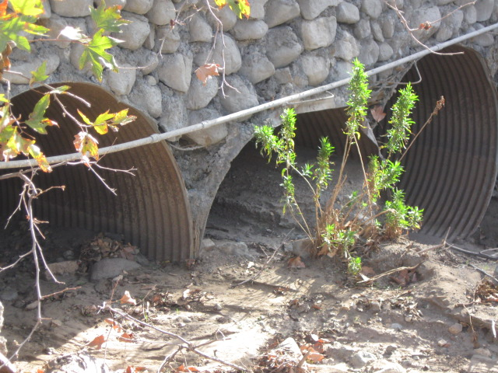

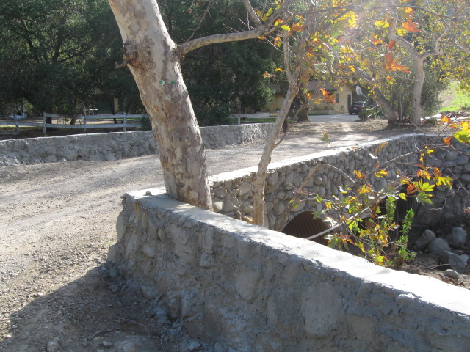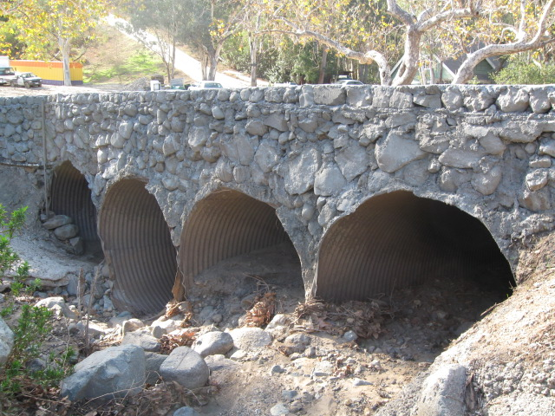

Date: 12/11/08

Case: CE080250

Address: 28512 Williams Cyn. Rd. Silverado

These pictures show the bridge next to Williams Cyn Rd.

